Day-35 Built in Function Python
Challenge 1: Flatten a Nested List
Concepts: list comprehension
Problem:
nested = [[1, 2], [3, 4], [5]]
Expected Output:
[1, 2, 3, 4, 5] 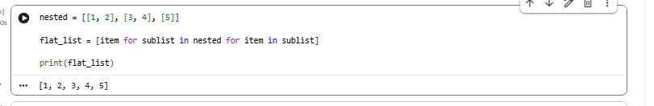

Challenge 2: Check Anagram
Concepts: sorted()
Problem:
Check if two strings are anagrams.
s1 = "listen" s2 = "silent"
Expected Output:
True
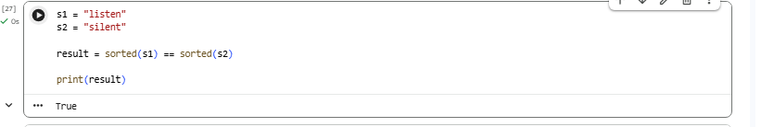

Challenge 3: Find Missing Number
Concepts: set() Problem:
nums = [1, 2, 4, 5]
Expected Output:
3
Hint:
Compare with full range using set difference.
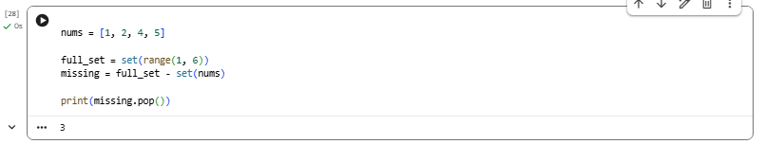
Challenge 4: Group Words by First Letter
Concepts: dict, setdefault()
Problem: words = ["apple", "ant", "banana", "bat"] Expected Output:
{'a': ['apple', 'ant'], 'b': ['banana', 'bat']}
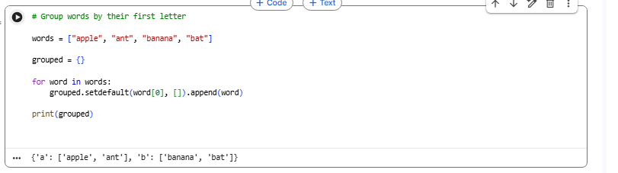

Challenge 5: Remove Empty Values
Concepts: dictionary comprehension
Problem:
data = {"a": 1, "b": None, "c": 3, "d": None}
Expected Output:
{'a': 1, 'c': 3}
